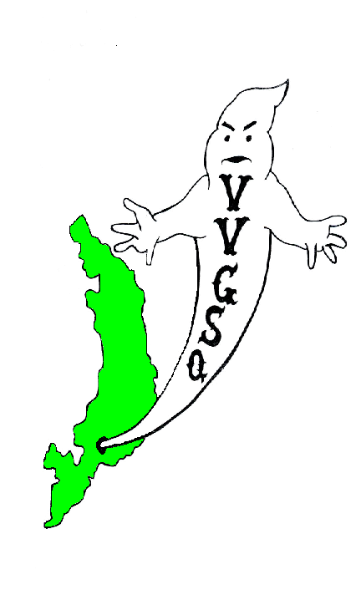
Vietnam Veterans Group of San Quentin

February 2012 General Meeting
Held in the Library on February 26, 2012.

EXECUTIVE COMMITTEE:

Chairman | Ron Self
Vice-Chairman | Barry Spillman
Secretary/Treasurer | Dave Basile
Outside Coordinator | Ron Self (Acting)
North Block Member-at-Large | Malcolm Jones
H-Unit Member at Large | Anthony Parker
West Block Member at Large | Harry Barton

Chairman Ron Self called the meeting to order at 0907 hrs. Roll was called: 37 members present and 5 absent - there was a quorum. Our sponsor, Lt. K. Evans, was present. In addition, Operation Moms Representative Gloria Godchaux and Website/Historian JLynn Manley was present - thank you for joining us.

All present were asked to remove their hats for a moment of silence for those Missing-in-Action, those Killed-in-Action, and all other service members deployed in Iraq, Afghanistan, and around the world.

All members were asked if they received the January 2012 General Meeting minutes. All members did receive their minutes and no corrections were requested. A motion to accept the minutes requested Mr. Rooke; seconded by Mr. Parker, and the motion passed.

SECRETARY/TREASURER'S REPORT:
Mr. Dave Basile: We have $408.15 in our account as of 2/22/2012.

OUTSIDE COORDINATOR’S REPORT:
Mr. Self: The following correspondence received since our last meeting:

United Veterans of America Freeport, Florida
Chaplain Phillip Carter, NIV Savoy, Texas
Bill Anderson Seattle, Wash.
George Hoppen, Jewish war Veterans Boca Raton, Fla.
Herb Sallie Jr. Menlo Park, Ca.
Chaplin Caleb, USA, Vietnam Veteran North Carolina
TroopsDirect Website San Ramon, Ca
Debra Shelton Solano, Ca.

COMMITTEE REPORTS:

BY-LAWS:
Chairman Bob Kaser: Nothing new to report.

SCHOLARSHIP:
Chairman J. Robinson: Discussion with the assistant Food Manager produced the following as possible dinner for our banquet: Roast Beef, baked potato, asparagus, salad, cantaloupe, cottage cheese, ice cream with fruit toppings. As far as beverages are concerned, that will be looked at in the near future. All Scholarship applications have been processed. Gloria Godchaux donated 240 stamps for the letters. Thank you Gloria. Finally, thanks to Veteran Snider for a job well done.

VIP OFFICE:
The next workshop is scheduled for March 16, 2012.

COLOR GUARD:
Chairman Trent Capell: Speaking for Mr. Capell was Mr. Robinson. He asked if it was possible to add additional members to the Color Guard. He was informed that he could have up to 9 members in his committee.

HISTORIAN/WEBSITE:
JLynn Manley was informed that Chairman Self is trying to get a USB port or S-drive hooked up to his computer to transfer data to make updating our Website easier and more efficient.

STAMPS FOR SOLDIERS:
Mr. Rooke stated that for West Block, H-Unit and the Visiting Room are now up. He requested and received 25 large manila envelopes. It was also noted that Debra Shelton sent stamps to us from Solano State Prison; Thanks Debra.

CAMARADERIE NIGHT:
Camaraderie night is officially on stand down until will get an approved sponsor.

PRESENTATION BOXES:
Chairman Schuhmacher stated that Machine Shop Vocational Instructor, R. Sanez, received the designs for the tops of the presentation boxes. Currently, they are practicing transferring the military logos through the engraving process.

OPERATION MOM

Gloria stated that there was nothing new to report.

OLD BUSINESS:

Secretary Basile conducted the voting on returning members J.D. Martin and G. Johnson. In accordance with By-Law Revision (9/11), members who transfer non-adversely and return to San Quentin no longer are required probationary status. Both Veteran members Martin and Johnson fall under this revision and voted in by the General Membership. Spooky pins and Scholarship pins were passed out to those whose trust withdrawals cleared accounting. More pins are available for those interested.

NEW BUSINESS:

Secretary Basile had the following new members report: Veterans Soltero USAF, Coleman, USN and Woods, US Army. All were welcomed and invited to participate in the VVGSQ’s worthy endeavors. Veteran Baer asked when the Scholarship Banquet will be held. The date is June 16, 2012. Veteran Johnson asked about holding a special election for the Outside Coordinators position. Mr. Johnson also brought up the DD214 issue. As it stands now, and to my knowledge, the only valid DD214 is one with an embossed seal

Chairman Self thanked the Sponsors for attending on behalf of the entire group.

A motion to adjourn the meeting by Mr. Sanders and seconded by Mr.Rooke. A vote was taken and the motion passed. The meeting adjourned at 0955 hrs.

UPCOMING EVENTS

March 25, 2012 | General Meeting in the Library @ 0900 hrs
April 29, 2012 | General Meeting in the Library @ 0900 hrs
May 27, 2012 | General Meeting in the Library @ 0900 hrs
June 16, 2012 | Scholarship Banquet, Visiting Room San Quentin
June 24, 2012 | General Meeting in the Library @ 0900 hrs

Submitted,

__________________________ __________________
D. Basile, DATE
V.V.G.S.Q. Secretary / Treasurer

__________________________ __________________
R. G. Self DATE
V.V.G.S.Q. Chairman

NOTED

__________________________ __________________
K. Evans DATE
Correctional Lieutenant
V.V.G.S.Q. Chief Sponsor

Vietnam Veterans Group of San Quentin  Attn: Lt. K. Evans, Chief sponsor  San Quentin State Prison  1 Main Street  San Quentin, CA 94964-0001  Website: http://vvgsq.tripod.com/ | Chief Sponsor: Lt. K. Evans, (415) 454-1460 x 5205

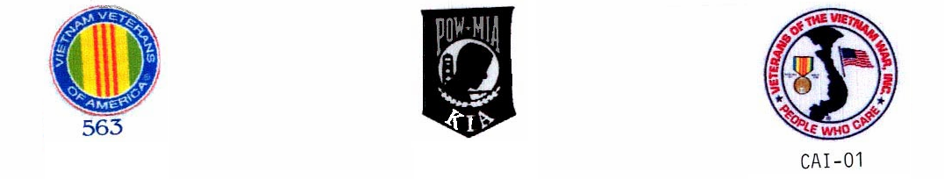
CURRENT ROSTER as of 2/26/12

 |  | NAME | CDC # | HOUSE | ETH. | CUST. | STATUS | COMMENTS
1 | √ | ADAMS DWIGHT | K-98701 | 1N073L | BLK | MEDA | Voting Mbr
2 | √ | ARNOLD, RICHARD | P-27171 | 2N069U | WHI | CLOB | Voting Mbr | VIG
3 | √ | BAER, STAN | K-06285 | 3N039U | WHI | MEDA | Voting Mbr | VIG,
4 | √ | BARTON, HARRY | C-03120 | 1W037L | WHI | MEDA | Voting Mbr | VIG,W-Blk Mber @ Large,
5 | √ | BASILE, DAVID | C-70016 | 1N038U | WHI | MEDA | Voting Mbr | VIG, Secretary/Treasurer
6 | √ | BEAVERS, LAWSON | P-14974 | 1N015L | BLA | CLOB | Voting Mbr | VIG, Color Guard
7 | A | BOTHA, GARY | D-88086 | 1N085L | WHI | MEDA | Voting Mbr | VIG, Scholarship
8 | √ | BROWN, DAVID | AE-3137 | 3W003L | BLA | MEDB | Voting Mbr
9 | A | BUTLER, DUANE S. | D-91464 | 2N017L | BLA | MEDA | Voting Mbr | VIG
10 | √ | CAFFALE, GEO | D-97941 | 3N008L | WHI | MEDA | Voting Mbr | VIG
11 | A | CAPELL, TRENTON | E-91949 | 3N011U | BLA | CLOB | Voting Mbr | Chairman Color Guard
12 | √ | COLEMAN, RONALD | C-87435 | 2W010L | BLA | MEDA | PROBATION | Probation until 5/27/12
13 | √ | COOPER, GARY | T-15604 | 3W013L | WHI | CLOB | PROBATION | Probationary until 4/29/12
14 | √ | FAISON, POPEYE | C-68462 | 2N028U | BLA | MEDA | Voting Mbr | Probationary until 4/29/12
15 | A | FARRIS, DARRYL | T-33812 | 5N071U | BLK | CLOB | PROBATION
16 | A | GOMEZ, JOHNNY | K-72622 | 4N042L | MEX | CLOB | Voting Mbr
17 | √ | GOODLOW, KENNETH | C-75705 | 3W102L | BLA | CLOB | PROBATION | Probationary until 4/29/12
18 | √ | GUMPAL, MAURO | P-00591 | 4N036L | OTH | CLOB | Voting Mbr
19 | √ | HERNANDEZ, JESSE | K-21116 | 2W036L | WHI | MEDA | PROBATION | Probationary until 4/29/12
20 | √ | HICKMAN, HUGH | K-32967 | 03H035L | BLA | MEDB | Voting Mbr
21 | √ | JOHNSON, CRAIG | C-08327 | 4W063L | WHI | MEDA | Voting Mbr
22 | √ | JONES, MALCOLM | J-04780 | 4N008L | BLA | CLOB | Voting Mbr | VIG, NB Member at Large
23 | √ | KASER, BOB | D-41415 | 2N025L | WHI | MEDA | Voting Mbr | VIG, Chairman Bylaws
24 | √ | KESS, PHILLIP | G-62396 | 05H024L | BLA | MEDB | Voting Mbr
25 | √ | MARTIN, J.D. | D-44170 | 4W075L | BLA | MEDA | Voting Mbr
26 | √ | PARKER, ANTHONY | D-20753 | 05H006L | BLA | MEDB | Voting Mbr | H-Unit Member at Large
27 | √ | POLLEY, AHMAD | C-57727 | 2W009L | BLA | MEDA | Voting Mbr | VIG, Color Guard
28 | √ | ROBINSON, GARVIN | K-52086 | 3N012L | BLA | CLOB | Voting Mbr | Scholarship Chairman, Color Grd
29 | √ | ROOKE, PETE | C-76159 | 1N020L | WHI | CLOB | Voting Mbr | Tabs/Stamps for Soldiers
30 | √ | SANDERS, GREG | E-05222 | 2W011L | WHI | MEDA | Voting Mbr | VIG, Outside Coordinator
31 | √ | SCHUHMACHER, CHRIS | T-31014 | 4N093L | WHI | MEDA | Voting Mbr | Presentation Box Chairman
32 | √ | SELF, RONALD | K-21055 | 4N083L | AMI | CLOB | Voting Mbr | VIG, VIP, Chairman
33 | √ | SNIDER, JAMES | F-30077 | 2N100U | WHI | CLOB | Voting Mbr | Scholarship
34 | √ | SOLTERO, DANIEL | D-65858 | 1W074U | WHI | CLOB | PROBATION | Probation until 5/27/12
35 | √ | SPILLMAN, GLEN | F-42695 | 3N035U | WHI | CLOB | Voting Mbr | VIG, Vice Chairman
36 | √ | STAUFFER, PAUL | T-80750 | 3N065U | WHI | CLOB | Voting Mbr
37 | √ | STEWART, NORFLEET | E-90026 | 4W079L | BLA | CLOB | PROBATION | Probationary until 4/29/12
38 | √ | TARVIN, DAVID | E-76518 | 2W038L | WHI | MEDA | PROBATION | Probationary until 4/29/12
39 | √ | TREVENO, DANNY | J-93154 | 4W012L | AMI | CLOSB | Voting Mbr | Scholarship
40 | √ | VICK, ERNIE | P-59262 | 2N016L | WHI | CLOB | Voting Mbr | VIG, Scholarship
41 | √ | WARREN, JOHN | T-86358 | 04H065L | MEX | MEDB | Voting Mbr
42 | √ | WOODS. JIMMIE | V-68113 | 03H022 | BLA | MEDB | PROBATION | Probation until 5/27/12

√ = Present
E = Excused Absence
A = Unexcused Absence

